OPEN-SOURCE HARDWARE DEVELOPMENT
CORE FIELD: Biomedical Antenna Synthesis (Subcutaneous)
EM SOLVER: Ansys HFSS Finite Element Method (FEM)
REPOSITORY: https://github.com/apoorvabhat07/implantable-antenna-hfss-analysis

DESIGN AND EVALUATION OF A DETUNING-IMMUNE MICROPATCH ANTENNA FOR SUBCUTANEOUS TELEMETRY

An Ansys HFSS Electromagnetic Simulation Case Study

Key Specifications & Focus:
- Operating Frequency: $600\text{ MHz}$ Band Optimization
- Footprint Architecture: Compact $14\text{ mm}×14\text{ mm}$ Patch on $60\text{ mm}×60\text{ mm}$ Tissue Grid
- Analysis Core: 5-Iteration Parametric Sweep ($5\text{ mm}-15\text{ mm}$ Variable Fat Boundaries)
- Feature Integration: Dielectric Bio ceramic Shielding for Detuning Immunity

Designed & Developed By:
APOORVA BHAT
Electronics & Communication Engineering Enthusiast
JULY 2026

TABLE OF CONTENTS
SL. NO. | TECHNICAL SECTION / TITLE | PG NO.
i. | ABSTRACT | 3
1. | INTRODUCTION  1.1 Introduction  1.2 Problem Statement  1.3 Aim  1.4 Objectives  1.5 Scope of the Work | 4-5
2. | DESIGN OVERVIEW  2.1 Introduction  2.2 Proposed Antenna Design  2.3 Biological Tissue Model  2.4 Simulation Environment  2.5 Overall Workflow  2.6 Summary | 6-7
3. | ANTENNA DESIGN AND SIMULATION METHODOLOGY  3.1 Introduction  3.2 Development of the Biological Tissue Model  3.3 Development of the Antenna Structure  3.4 Material Assignment  3.5 Excitation and Boundary Conditions  3.6 Simulation Configuration  3.7 Parametric Analysis  3.8 HFSS Model (Figures 3.1 & 3.2)  3.9 Summary | 8-11
4. | ANTENNA DESIGN CALCULATIONS  4.1 Introduction  4.2 Design Specifications (Table 4.1)  4.3 Antenna Dimension Calculations (Table 4.2)  4.4 Summary | 12-14
5. | RESULTS AND DISCUSSION  5.1 Return Loss ($S_{11}$) Analysis (Table 5.1 / Figure 5.1)  5.2 Voltage Standing Wave Ratio (VSWR) Analysis (Table 5.2 / Figure 5.2)  5.3 Input Impedance Analysis (Table 5.3 / Figure 5.3)  5.4 Far-Field Gain Analysis (Table 5.4 / Figure 5.4)  5.5 Radiation Pattern Analysis (Figure 5.5)  5.6 Overall Performance Evaluation | 15-19
6. | CONCLUSION AND FUTURE SCOPE  6.1 Conclusion  6.2 Future Scope | 20-21
7. | REFERENCES | 22

ABSTRACT
Implantable antennas have become an important component of modern biomedical systems by enabling wireless communication between implanted medical devices and external monitoring equipment. These antennas facilitate continuous health monitoring, medical data transmission, and remote diagnosis while minimizing the need for invasive procedures. The performance of an implantable antenna is significantly influenced by the surrounding biological tissues, making it essential to evaluate its characteristics under realistic human tissue conditions.
This project presents the design and simulation of a compact implantable microstrip patch antenna operating in the MedRadio frequency band around 600 MHz using Ansys HFSS 2025 R2. The antenna is designed on a Teflon (PTFE) substrate and analysed within a multilayer human tissue model consisting of skin, fat, and muscle layers. To investigate the influence of anatomical variations on antenna performance, a parametric analysis was carried out by varying the fat layer thickness from 5 mm to 15 mm while maintaining the remaining tissue dimensions constant.
The antenna performance was evaluated using key parameters such as return loss (S11), Voltage Standing Wave Ratio (VSWR), input impedance, far-field gain, and radiation pattern characteristics. The simulation results demonstrated stable resonant frequencies between 590.53 MHz and 601.00 MHz for all investigated tissue configurations. The antenna achieved return loss values better than −16 dB, VSWR values between 1.25 and 1.33, and input impedance values close to the desired feed impedance, indicating effective impedance matching and efficient power transfer. Although the simulated far-field gain was reduced due to the lossy nature of biological tissues, the radiation patterns remained stable and exhibited broadside radiation characteristics suitable for implantable communication.
The obtained results demonstrate that the proposed implantable antenna maintains reliable performance under varying tissue conditions and is suitable for low-power biomedical telemetry and wireless health monitoring applications operating in the MedRadio frequency band.

1. INTRODUCTION

1.1 Introduction
Implantable antennas have become an integral component of modern biomedical communication systems, enabling wireless communication between implantable medical devices and external monitoring equipment. They are widely employed in applications such as physiological monitoring, neural interfaces, drug delivery systems, and implantable sensors, where reliable wireless communication is essential for continuous data transmission and patient care.
Unlike conventional antennas operating in free space, implantable antennas function within the human body, where electromagnetic waves propagate through biological tissues with varying dielectric properties. The electrical characteristics of tissues such as muscle, fat, and skin influence the resonant frequency, impedance matching, and radiation performance of the antenna. Since the composition and thickness of these tissues vary among individuals, the electromagnetic behaviour of an implantable antenna may also change after implantation.
To investigate these effects, a compact implantable microstrip patch antenna operating at 600 MHz was designed and analysed using Ansys HFSS Student Edition. A multilayer biological tissue model consisting of muscle, fat, and skin was developed to represent the implantation environment. A Teflon (PTFE) superstrate was incorporated above the radiating patch as part of the antenna structure, and a metallic cylindrical element was included within the model to represent the implant configuration used in the simulation.
The performance of the antenna was evaluated by performing a parametric analysis in which the fat layer thickness was varied while all other design parameters remained unchanged. The simulation results were used to examine the influence of tissue variation on the electromagnetic performance of the antenna.

1.2 Problem Statement
The electromagnetic performance of an implantable antenna is significantly influenced by the dielectric properties of the surrounding biological tissues. Variations in tissue composition, particularly the thickness of the fat layer, can alter the resonant frequency, impedance characteristics, and radiation behaviour of the antenna, potentially affecting the reliability of wireless communication.
Designing an implantable antenna that maintains consistent performance under varying tissue conditions is therefore an important consideration in biomedical antenna design. This project addresses this challenge by investigating the influence of fat layer thickness on the performance of a compact implantable microstrip patch antenna through electromagnetic simulation.

1.3 Aim
To design and analyse a compact implantable microstrip patch antenna operating at 600 MHz using Ansys HFSS Student Edition and evaluate the effect of varying fat layer thickness on its electromagnetic performance.

1.4 Objectives
The objectives of this project are:
- To design a compact implantable microstrip patch antenna for biomedical communication applications.
- To develop a multilayer biological tissue model consisting of muscle, fat, and skin.
- To incorporate a Teflon (PTFE) superstrate into the antenna structure.
- To perform a parametric analysis by varying the fat layer thickness from 5 mm to 15 mm.
- To evaluate the antenna performance using reflection coefficient (S₁₁), Voltage Standing Wave Ratio (VSWR), input impedance, and radiation characteristics.
- To analyse the influence of fat layer thickness on the overall electromagnetic performance of the antenna.

1.5 Scope of the Work
This project focuses on the design and electromagnetic simulation of a compact implantable microstrip patch antenna using Ansys HFSS Student Edition. The antenna is analysed within a simplified multilayer biological tissue model comprising muscle, fat, and skin. A parametric study is carried out by varying the thickness of the fat layer while maintaining all other antenna dimensions and simulation parameters constant.
The antenna performance is evaluated using standard antenna parameters obtained through simulation. The work is limited to electromagnetic analysis and does not include antenna fabrication, experimental validation, or Specific Absorption Rate (SAR) analysis.

2. DESIGN OVERVIEW

2.1 Introduction
This chapter provides an overview of the proposed implantable microstrip patch antenna developed for biomedical communication applications. The antenna was designed to operate at 600 MHz within a multilayer biological tissue environment representing the human body. A simplified tissue model consisting of muscle, fat, and skin was created to simulate the implantation conditions, while a Teflon (PTFE) superstrate was incorporated above the radiating patch as part of the antenna structure.
The antenna model was developed and analysed using Ansys HFSS Student Edition. A parametric analysis was carried out to study the effect of varying fat layer thickness on the electromagnetic performance of the antenna while maintaining all other design parameters constant.

2.2 Proposed Antenna Design
The proposed design consists of a compact microstrip patch antenna integrated with a multilayer biological tissue model. The antenna structure comprises a metallic ground plane, a square radiating patch, a Teflon (PTFE) superstrate, and a metallic cylindrical element positioned within the tissue model.
The biological tissue model consists of three layers representing muscle, fat, and skin, arranged sequentially to approximate the implantation environment. The antenna is positioned above the tissue model and excited using a lumped port with a characteristic impedance of 50 Ω. The complete structure is enclosed within a radiation region to simulate electromagnetic wave propagation under open-boundary conditions.
The design was developed to provide a compact simulation model while enabling the influence of biological tissue variation on antenna performance to be investigated through parametric analysis.

2.3 Biological Tissue Model
A simplified multilayer tissue model was developed to represent the surrounding biological environment of the implantable antenna. The model consists of three tissue layers: muscle, fat, and skin.
The muscle layer forms the base of the model and represents the deeper biological tissue. The fat layer is positioned above the muscle and serves as the variable parameter in this study. The skin layer forms the outer boundary of the tissue model and completes the simulated implantation environment.
To investigate the effect of tissue variation, the fat layer thickness was varied from 5 mm to 15 mm while all remaining model parameters were maintained constant. This approach enabled a systematic evaluation of the influence of fat thickness on the antenna characteristics.

2.4 Simulation Environment
The antenna was designed and analysed using Ansys HFSS Student Edition, a three-dimensional electromagnetic simulation software based on the Finite Element Method (FEM). The software provides accurate modelling of antenna structures operating in complex dielectric environments.
The simulations were performed using the Terminal Solution type. A frequency sweep covering the operating range of the antenna was carried out to analyse its electromagnetic behaviour. The Optimetrics module was used to perform the parametric analysis by varying the fat layer thickness while maintaining all other simulation parameters unchanged.

2.5 Overall Workflow
The overall methodology adopted in this project consisted of the following stages:
- Selection of the operating frequency and antenna configuration.
- Development of the multilayer biological tissue model.
- Design of the implantable microstrip patch antenna.
- Assignment of material properties and electromagnetic boundary conditions.
- Configuration of the simulation environment in Ansys HFSS Student Edition.
- Execution of the parametric analysis by varying the fat layer thickness.
- Evaluation of the simulation results and comparison of the antenna performance for different tissue configurations.

2.6 Summary
This chapter presented an overview of the proposed implantable microstrip patch antenna and the biological tissue model developed for the study. The overall antenna configuration, simulation environment, and workflow adopted for the investigation were described. The following chapter details the methodology used to construct the antenna model, assign material properties, configure the simulation environment, and perform the parametric analysis using Ansys HFSS Student Edition.

3. ANTENNA DESIGN AND SIMULATION METHODOLOGY

3.1 Introduction
This chapter describes the methodology adopted for the design and simulation of the proposed implantable microstrip patch antenna using Ansys HFSS Student Edition. The modelling process includes the development of the biological tissue model, construction of the antenna geometry, assignment of material properties, definition of excitation and boundary conditions, configuration of the simulation environment, and execution of the parametric analysis. The methodology was developed to evaluate the influence of varying fat layer thickness on the electromagnetic performance of the antenna under controlled simulation conditions.

3.2 Development of the Biological Tissue Model
The biological tissue model was developed using three stacked rectangular layers representing muscle, fat, and skin. These layers were arranged vertically to approximate the implantation environment surrounding the antenna.
The muscle layer was created first to serve as the foundation of the tissue model. The fat layer was then positioned above the muscle layer and defined as the variable parameter for the study. Finally, the skin layer was placed above the fat layer to complete the multilayer structure.
The overall tissue model occupied a square footprint of 60 mm × 60 mm. The muscle and skin layer thicknesses remained constant throughout the study, while the fat layer thickness was varied during the parametric analysis. The dimensions were selected to provide sufficient surrounding tissue for electromagnetic simulation while remaining within the computational limitations of Ansys HFSS Student Edition.

3.3 Development of the Antenna Structure
Following the construction of the tissue model, the antenna structure was developed. A metallic ground plane was positioned beneath the biological tissue model to provide the reference conductor for the antenna. The radiating element, consisting of a square microstrip patch, was placed above the tissue layers.
A Teflon (PTFE) superstrate was incorporated above the radiating patch as part of the antenna structure. In addition, a metallic cylindrical element was positioned centrally within the fat layer to represent the intended implant configuration considered in this study.
The geometry of the antenna remained unchanged throughout the investigation, ensuring that the effect of fat layer thickness could be analysed independently of any structural modifications.

3.4 Material Assignment
Material properties were assigned to all components of the simulation model to represent the intended operating environment.
The biological tissue layers were assigned dielectric properties corresponding to muscle, fat, and skin. The antenna patch and ground plane were modelled as Perfect Electric Conductors (PEC) to represent metallic conducting surfaces. The superstrate was assigned the material properties of Teflon (PTFE), while the metallic cylindrical element was assigned an appropriate conducting material.
These material assignments enabled the interaction between the antenna and the surrounding biological tissues to be evaluated under realistic electromagnetic conditions.

3.5 Excitation and Boundary Conditions
The antenna was excited using a lumped port with a characteristic impedance of 50 Ω. The excitation was applied through a feed structure connecting the radiating patch to the ground plane.
To simulate electromagnetic wave propagation in an open environment, the complete antenna model was enclosed within a radiation region. Radiation boundary conditions were assigned to the outer surfaces of the computational domain to minimise reflections from the simulation boundaries.
The excitation method and boundary conditions remained unchanged for every simulation case to ensure consistency throughout the parametric analysis.

3.6 Simulation Configuration
The simulations were performed using the Terminal Solution type available in Ansys HFSS Student Edition.
An adaptive solution frequency of 600 MHz was selected for the analysis. The solution setup employed a maximum of ten adaptive passes with a convergence criterion of ΔS equal to 0.02. These settings provided a balance between simulation accuracy and the computational limitations of the student version.
A frequency sweep was performed from 200 MHz to 800 MHz using an interpolating sweep. This frequency range was selected to evaluate the resonance characteristics of the antenna around its intended operating frequency.

3.7 Parametric Analysis
A parametric analysis was carried out using the Optimetrics module available in Ansys HFSS Student Edition.
The fat layer thickness was selected as the design variable and varied from 5 mm to 15 mm in increments of 2.5 mm, resulting in five different simulation configurations. Throughout the analysis, the antenna geometry, material assignments, excitation method, and simulation settings were maintained constant.
The simulation results obtained for each configuration were compared to evaluate the influence of fat layer thickness on the electromagnetic performance of the antenna.

3.8 HFSS Model
After completing the geometry construction and simulation setup, the model was verified within Ansys HFSS Student Edition prior to analysis. The verification process ensured the correct alignment of all components, proper material assignments, and accurate placement of the excitation and boundary conditions.
The complete antenna assembly and tissue model are illustrated in Figure 3.1, while the cross-sectional arrangement of the tissue layers and antenna components is presented in Figure 3.2.
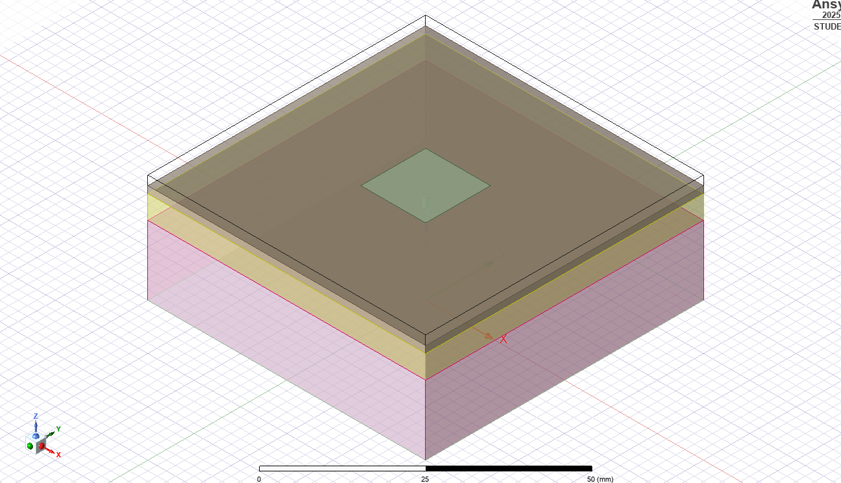
Figure 3.1 Overall Isometric View of the Proposed Implantable Microstrip Patch Antenna
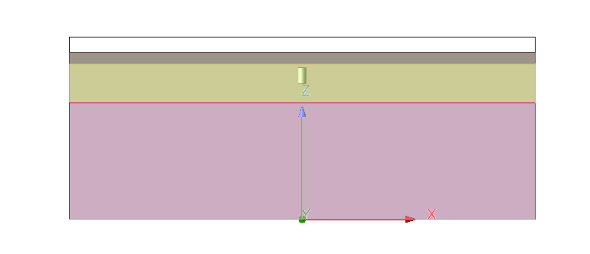Figure 3.2 Cross-Sectional View of the Proposed Implantable Microstrip Patch Antenna

3.9 Summary
This chapter presented the methodology adopted for the design and simulation of the proposed implantable microstrip patch antenna. The development of the biological tissue model, construction of the antenna geometry, material assignments, excitation method, boundary conditions, simulation configuration, and parametric analysis were described. The resulting HFSS model formed the basis for evaluating the influence of fat layer thickness on antenna performance. The theoretical design calculations used to determine the antenna dimensions are presented in the following chapter.

4. ANTENNA DESIGN CALCULATIONS

4.1 Introduction
This chapter presents the design calculations used to determine the dimensions of the proposed implantable microstrip patch antenna. The antenna was designed to operate at a centre frequency of 600 MHz using the conventional microstrip patch antenna design procedure. The calculated dimensions served as the initial design parameters for developing the antenna model in Ansys HFSS Student Edition. Minor dimensional adjustments were subsequently made during simulation to obtain the desired resonant characteristics.

4.2 Design Specifications
The initial antenna dimensions were determined based on the design specifications listed in Table 4.1.
Parameter | Specification
Antenna Type | Microstrip Patch Antenna
Operating Frequency | 600 MHz
Feeding Technique | Lumped Port
Simulation Software | Ansys HFSS Student Edition
Ground Plane | Perfect Electric Conductor (PEC)
Superstrate Material | Teflon (PTFE)
Biological Tissue Layers | Muscle, Fat and Skin
Table 4.1 Design Specifications of the Proposed Antenna

4.3 Antenna Dimension Calculations
The dimensions of the microstrip patch antenna were determined using the standard transmission line model equations. These calculations provide the initial dimensions of the antenna prior to simulation-based optimisation.
The free-space wavelength is given by
$$λ_{0}=\frac{c}{f}$$
where
- $c=3×{10}^{8}$m/s
- $f=600×{10}^{6}$Hz

Substituting the values,
$$λ_{0}=\frac{3×{10}^{8}}{600×{10}^{6}}$$
$$λ_{0}=0.5\text{ m}=500\text{ mm}$$

The width of the rectangular patch is calculated using
$$W=\frac{c}{2f}\sqrt{\frac{2}{ε_{r}+1}}$$
where
- $W$= Patch width
- $c$= Speed of light
- $f$= Operating frequency
- $ε_{r}$= Relative permittivity of the substrate
The effective dielectric constant is calculated as
$$ε_{eff}=\frac{ε_{r}+1}{2}+\frac{ε_{r}-1}{2}{\left(1+\frac{12h}{W}\right)}^{-1/2}$$
where
- $h$= Substrate thickness
The fringing field extension is determined using
$$ΔL=0.412h\frac{\left(ε_{eff}+0.3\right)\left(\frac{W}{h}+0.264\right)}{\left(ε_{eff}-0.258\right)\left(\frac{W}{h}+0.8\right)}$$
The effective patch length is calculated as
$$L_{eff}=\frac{c}{2f\sqrt{ε_{eff}}}$$
The actual patch length is then obtained using
$$L=L_{eff}-2ΔL$$
The calculated dimensions obtained from these equations were used as the initial design values for constructing the antenna model. The geometry was subsequently refined during simulation to achieve resonance near the desired operating frequency.
The final dimensions adopted for the proposed antenna are summarised in Table 4.2.
Parameter | Final Value
Patch Length | 14 mm
Patch Width | 14 mm
Tissue Width | 60 mm
Muscle Thickness | 15 mm
Fat Thickness | 5–15 mm
Skin Thickness | 1.5 mm
Teflon (PTFE) Superstrate Thickness | 2 mm
Table 4.2 Final Dimensions of the Proposed Antenna Model

4.4 Summary
This chapter presented the theoretical calculations used to determine the initial dimensions of the proposed implantable microstrip patch antenna. The calculated dimensions served as the starting point for constructing the antenna model in Ansys HFSS Student Edition. Following simulation-based refinement, the final antenna dimensions were established and used for the parametric analysis presented in the next chapter.

5. RESULTS AND DISCUSSION
The proposed implantable microstrip patch antenna was simulated using Ansys HFSS 2025 R2 to evaluate its performance under varying biological tissue conditions. A parametric analysis was carried out by varying the fat layer thickness from 5 mm to 15 mm, while keeping all other antenna and tissue parameters constant. The antenna performance was evaluated using the reflection coefficient (S11), Voltage Standing Wave Ratio (VSWR), input impedance, far-field gain and radiation pattern characteristics.

5.1 Return Loss (S11) Analysis
The reflection coefficient (S11) was analysed to evaluate the impedance matching performance of the proposed antenna for different fat layer thicknesses. The resonant frequency and corresponding minimum return loss obtained from the simulations are listed in Table 5.1.
Fat Thickness (mm) | Resonant Frequency (MHz) | Minimum S11 (dB)
5.0 | 590.53 | -17.68
7.5 | 601.00 | -17.82
10.0 | 598.01 | -16.92
12.5 | 595.01 | -17.69
15.0 | 590.53 | -19.12
Table 5.1: Simulated resonant frequency and minimum return loss for different fat layer thicknesses.
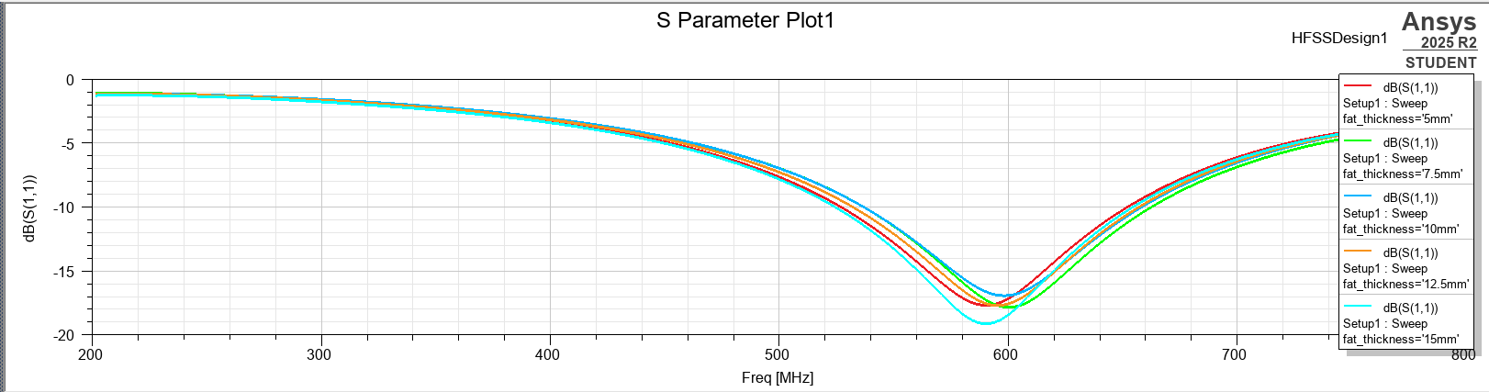Figure 5.1: Simulated S11 characteristics of the proposed implantable antenna for different fat layer thicknesses.
The simulated antenna resonates between 590.53 MHz and 601.00 MHz, remaining close to the intended operating frequency of 600 MHz. The maximum resonant frequency variation is approximately 10.47 MHz, indicating that changes in fat layer thickness have only a minor influence on the resonant behaviour.
All simulated configurations exhibit return loss values below −10 dB, confirming satisfactory impedance matching. The minimum reflection coefficient of −19.12 dB is obtained for the 15 mm fat layer, while the 10 mm configuration produces the highest return loss of −16.92 dB. Nevertheless, all configurations satisfy the impedance matching requirement for reliable implantable antenna operation.

5.2 Voltage Standing Wave Ratio (VSWR) Analysis
The Voltage Standing Wave Ratio (VSWR) was evaluated to verify the quality of impedance matching between the antenna and the feeding structure. The minimum VSWR values obtained at the resonant frequencies are presented in Table 5.2.
Fat Thickness (mm) | Resonant Frequency (MHz) | Minimum VSWR
5.0 | 590.53 | 1.30
7.5 | 601.00 | 1.29
10.0 | 598.01 | 1.33
12.5 | 595.01 | 1.30
15.0 | 590.53 | 1.25
Table 5.2: Minimum VSWR obtained for different fat layer thicknesses.
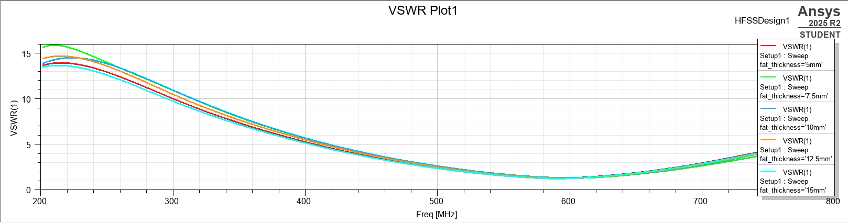Figure 5.2: Simulated VSWR characteristics of the proposed implantable antenna.
The obtained VSWR values range from 1.25 to 1.33, which are significantly lower than the acceptable design limit of 2.0. These results indicate excellent impedance matching and efficient power transfer for all investigated tissue conditions.
The lowest VSWR of 1.25 is achieved for the 15 mm fat layer, while the highest VSWR of 1.33 occurs for the 10 mm fat layer. The small variation in VSWR demonstrates that the antenna maintains stable matching characteristics despite changes in the surrounding biological tissue thickness.

5.3 Input Impedance Analysis
The input impedance of the proposed antenna was evaluated at the resonant frequency for each fat layer thickness. The real and imaginary components of the input impedance are summarised in Table 5.3.
Fat Thickness (mm) | Resonant Frequency (MHz) | Resistance (Ω) | Reactance (Ω)
5.0 | 590.53 | 63.15 | 0.00
7.5 | 601.00 | 62.59 | 0.00
10.0 | 598.01 | 64.49 | 0.00
12.5 | 595.01 | 63.26 | 0.00
15.0 | 590.53 | 60.96 | 0.00
Table 5.3: Input impedance of the proposed antenna at resonance for different fat layer thicknesses.
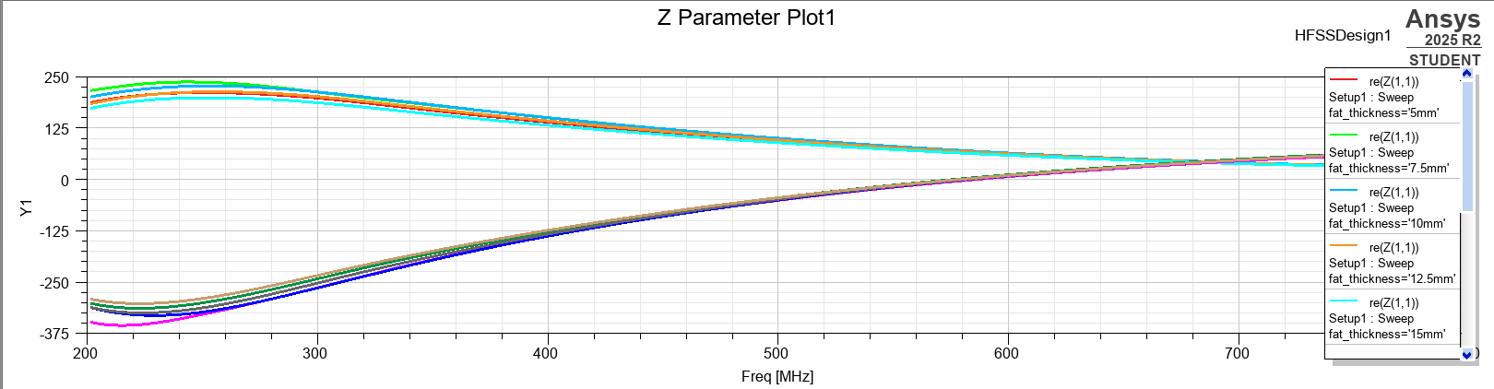Figure 5.3: Simulated input impedance characteristics of the proposed implantable antenna.
The simulated input resistance varies between 60.96 Ω and 64.49 Ω, remaining close to the desired feed impedance. The input reactance is 0 Ω for every configuration at resonance, confirming purely resistive operation at the resonant frequency. These results indicate efficient power transfer and proper resonance for all simulated tissue conditions.

5.4 Far-Field Gain Analysis
The far-field gain characteristics of the proposed implantable antenna were evaluated at 600 MHz for different fat layer thicknesses. The peak gain values extracted from the simulated radiation patterns are listed in Table 5.4.
Fat Thickness (mm) | Peak Gain (dB)
5.0 | -34.15
7.5 | -33.07
10.0 | -33.01
12.5 | -32.55
15.0 | -31.73
Table 5.4: Peak far-field gain for different fat layer thicknesses.
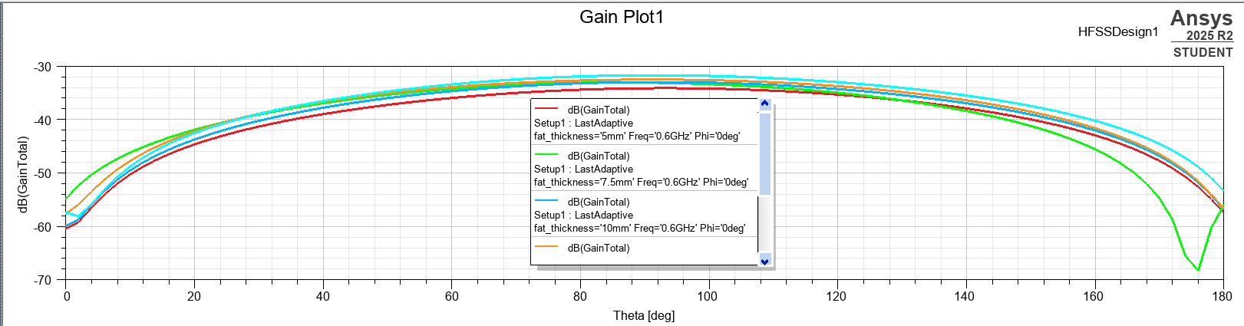Figure 5.4: Simulated two-dimensional far-field gain pattern of the proposed implantable antenna at 600 MHz.
The simulated peak gain varies from −34.15 dB to −31.73 dB as the fat layer thickness increases from 5 mm to 15 mm. This gradual improvement indicates that the surrounding tissue composition influences the radiation characteristics; however, the variation remains limited. The low gain values are expected because the antenna operates inside highly lossy biological tissues, where a considerable portion of the radiated electromagnetic energy is absorbed before reaching free space.

5.5 Radiation Pattern Analysis
The radiation characteristics of the proposed antenna were further analysed using the three-dimensional far-field radiation pattern generated at the operating frequency of 600 MHz.
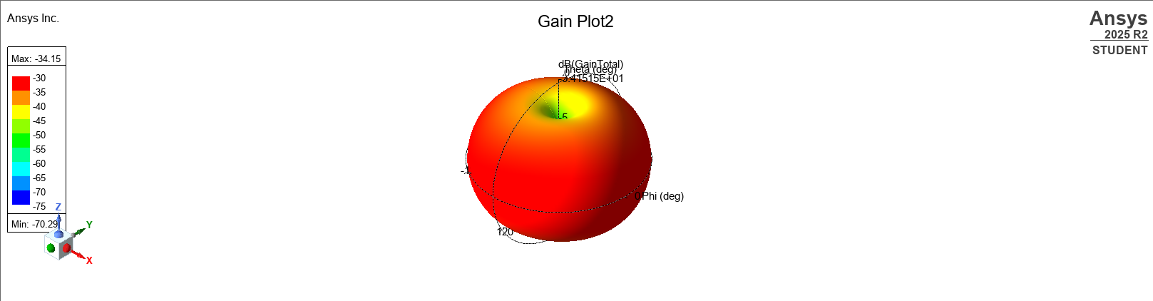Figure 5.5: Three-dimensional radiation pattern of the proposed implantable antenna at 600 MHz.
The two-dimensional radiation pattern exhibits a smooth broadside response with the maximum radiation occurring near θ = 90°. The closely overlapping radiation curves obtained for different observation planes demonstrate good pattern symmetry and stable radiation characteristics. The absence of significant side lobes indicates that the antenna maintains a consistent radiation profile under varying tissue conditions.
The three-dimensional radiation pattern further confirms the broadside behaviour of the antenna, exhibiting a single dominant radiation lobe with no significant secondary lobes. Although the surrounding biological tissues introduce substantial attenuation, the overall radiation pattern remains stable, making the antenna suitable for implantable biomedical communication.

5.6 Overall Performance Evaluation
The overall performance of the proposed implantable microstrip patch antenna was evaluated by analysing the return loss, VSWR, input impedance and radiation characteristics under varying fat layer thicknesses.
The antenna maintained resonant frequencies between 590.53 MHz and 601.00 MHz, with all configurations exhibiting return loss values better than −16 dB and VSWR values between 1.25 and 1.33. The input impedance remained close to the desired feed impedance, with resistance values ranging from 60.96 Ω to 64.49 Ω, while the reactance remained 0 Ω at resonance.
The far-field gain varied from −34.15 dB to −31.73 dB, and the radiation patterns consistently exhibited broadside characteristics with stable angular behaviour. These results demonstrate that the proposed implantable antenna achieves reliable impedance matching and stable radiation performance despite variations in the surrounding biological tissue thickness.

6. CONCLUSION AND FUTURE SCOPE

6.1 Conclusion
This project presented the design, simulation and performance evaluation of a compact implantable microstrip patch antenna intended for biomedical wireless communication in the MedRadio frequency band around 600 MHz. The antenna was designed on a Teflon substrate and analysed using Ansys HFSS 2025 R2 within a multilayer human tissue model consisting of skin, fat and muscle. A parametric study was carried out by varying the fat layer thickness from 5 mm to 15 mm to investigate the influence of anatomical variations on antenna performance.
The simulation results demonstrate that the proposed antenna successfully maintains stable operation across all investigated tissue configurations. The resonant frequency remained between 590.53 MHz and 601.00 MHz, indicating only a minor frequency shift due to changes in the surrounding tissue environment. The return loss values ranged from −16.92 dB to −19.12 dB, confirming satisfactory impedance matching throughout the parametric study. Similarly, the simulated VSWR values varied only between 1.25 and 1.33, demonstrating efficient power transfer with minimal reflected energy.
The input impedance remained nearly constant, with resistance values ranging from 60.96 Ω to 64.49 Ω, while the input reactance was 0 Ω at resonance for all simulated cases. This confirms proper resonant operation and effective impedance matching under varying biological tissue conditions.
The far-field gain varied from −34.15 dB to −31.73 dB. Although these values are lower than those of conventional free-space antennas, they are consistent with the expected performance of implantable antennas operating inside highly lossy biological tissues, where significant electromagnetic energy is absorbed by the surrounding medium. The radiation patterns exhibited stable broadside characteristics with good symmetry and no significant distortion, indicating reliable radiation performance suitable for implantable communication systems.
Overall, the simulation results demonstrate that the proposed antenna satisfies the primary design objectives for implantable biomedical applications by providing stable resonant characteristics, efficient impedance matching and consistent radiation behaviour under different tissue conditions.

6.2 Future Scope
Although the proposed antenna demonstrates satisfactory simulated performance, several improvements and extensions may be considered for future work to further enhance its practical applicability.
Future work may include fabrication of the antenna prototype followed by experimental validation using tissue-equivalent phantom models to compare measured results with the simulated performance. Such validation would provide greater confidence in the practical implementation of the antenna for biomedical applications.

The antenna design may also be further optimized to improve radiation efficiency and realized gain while maintaining compact dimensions suitable for implantation. Alternative substrate materials, biocompatible encapsulation techniques and modified patch geometries may be investigated to achieve improved performance.
Additional studies may be carried out by considering different implantation locations and more realistic multilayer anatomical models with varying tissue properties. The influence of patient-specific variations, tissue heterogeneity and implant orientation on antenna performance can also be investigated.
Future research may further include the evaluation of Specific Absorption Rate (SAR) to ensure compliance with international electromagnetic exposure standards for implantable medical devices. Mechanical flexibility, long-term biocompatibility and wireless link reliability may also be analysed for practical deployment.
Finally, the proposed antenna may be integrated with low-power implantable medical devices for applications such as continuous physiological monitoring, wireless health telemetry and next-generation implantable biomedical communication systems.

7. REFERENCES
[1] Dielectric Properties of Biological Tissues: II. Measurements in the Frequency Range 10 Hz to 20 GHz
https://iopscience.iop.org/article/10.1088/0031-9155/41/11/002
[2] Ansys Electronics Desktop (HFSS) Documentation
https://ansyshelp.ansys.com
[3] PubMed – Implantable Antennas for Biomedical Applications
https://pubmed.ncbi.nlm.nih.gov/?term=implantable+antenna+biomedical
[4] Rogers RT/Duroid® High Frequency Laminates Datasheet
https://rogerscorp.com/advanced-electronics-solutions/rt-duroid-laminates

